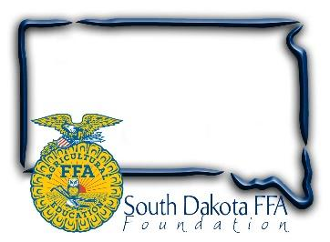
For Immediate Release
Contact: Gerri Ann Eide
605-765-4865
Gerri@sdffafoundation.org

FFA members package 48,300 meals during Living to Serve Day
(Bath, SD) – April 22, 2024 – The blue corduroy jacket is a familiar symbol of the FFA organization, worn as part of official dress during most FFA activities. On April 18th at the South Dakota FFA convention in Brookings, as part of a SD FFA Living to Serve Day, members removed their jackets and rolled up their sleeves to help stop hunger in South Dakota.
Working with industry and Meals of Hope, this South Dakota FFA Foundation hands-on project combats hunger. SD FFA members measured, poured, sealed, and boxed 48,300 meals in assembly line fashion. Members stopped in between workshops and competitive events throughout convention and left the event knowing that by giving a few minutes of their time they would make a significant difference in the life of a person less fortunate than themselves.
The Meals of Hope food packages are a hardy Pasta and Tomato Sauce meal. All of the 48,300 meals were donated to Feeding South Dakota based in Sioux Falls and will be distributed across our state. Jennifer Stensaas, Community Engagement Manager for Feeding South Dakota attended and expressed great appreciation for the event, the members' hard work, and SD FFA’s food donation. In addition, when asked how long the supply might last, Jennifer stated that during high need times it may only last 30-60 days.
Sandy Osterday, SD FFA Foundation board president and event chairman added, “The South Dakota FFA and FFA Foundation are proud to be able to have a part in providing quality food to families in need across our state. We are grateful for our sponsors who believe in our mission of Living to Serve. “
The South Dakota FFA Foundation received event funding through grants provided by the National FFA, Walmart of Brookings & Sioux Falls, and Corteva Agriscience’s, Pioneer seed team, who also provided area staff that were great hands-on help during the event.
The SD FFA Foundation supports Agricultural Education and the FFA's mission to make a difference in the lives of students by developing their potential for premier leadership, personal growth and career success through agricultural education. For more information about the South Dakota FFA Foundation and South Dakota's FFA programs, visit www.sdffafoundation.org or follow us on Facebook.
Photos: FFA members from across the state work together to measure, package and seal meals during the Day of Service, Meals of Hope Project at State FFA Convention.
# # #

